Ex. No.:5 Date:16/10/2015
Characteristics of MOSFET

Aim:To find the characteristic of MOSFET using Orcad software

Apparatus/Tool required:
ORCAD / Capture CIS -> PWRMOS Library – IRF840,
Source Library – Vdc, Vpulse
Ground (GND) – 0(zero)
Analog Library – R

Simulation Settings: Analysis Type - Time Domain
Run to time: 2ms

Circuit Diagram:

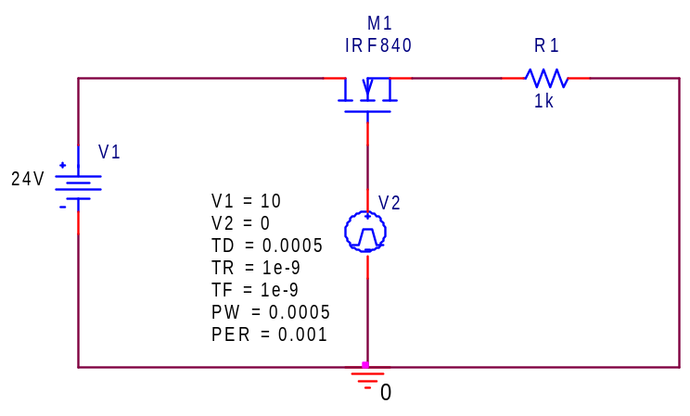

Theory:

The MOSFET (Metal Oxide Semiconductor Field Effect Transistor) is a semiconductor device which is widely used for switching and amplifying electronic signals in the electronic devices. It is a case of integrated circuits and it can be designed and fabricated in a single chip. Also, it is very different from common transistor and can be used in digital and analog both.

Model Waveform:
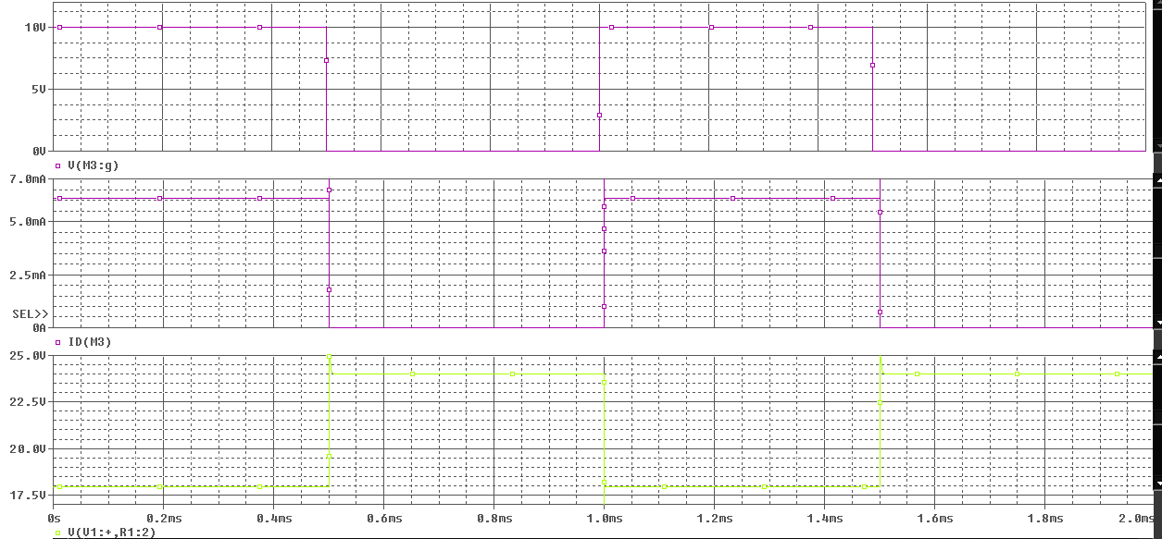

Observation Table:
Observation Table:
Time(ms) | Vin (in V) | Vout (in V)
0.2 | 10 | 0
0.4 | 10 | 0
0.6 | 0 | 24
0.8 | 0 | 24
1.0 | 0 | 24
1.2 | 10 | 0
1.4 | 10 | 0
1.6 | 0 | 24
1.8 | 0 | 24
2.0 | 0 | 24

Procedure:
- Open a Pspice project and construct the circuit as per the diagram.
- Run the simulation under the analysis type, time domain and run to time of 2 ms.
- Observe and verify the graph carefully and note down the values of Vin and Vout with respect to time.

Result:
The switching characteristics in MOSFET have been observed and verified using Pspice simulator and the graph is plotted.

Inference:
The value of the voltage through the MOSFET varies with the input voltage between cut off and saturation. This enables it to be used as switches. MOSFETs are widely used in computers to perform the function of logic gates instead of transistors.
